**Milestone 1, 2**

**Names and ids:**

Name1: البراء مصطفى محمد

ID1: 22010636

Name2: فاروق اشرف فاروق

ID2: 22011012

Name3: على مصطفى محمد بسيونى محمد

ID3: 22010939

Name4: ايمن ابراهيم محمد قطب

ID4: 22010656

Name5: عبد الرحمن السيد صديق

ID5: 22010870

Name6: عبد الرحمن سعيد رمضان جمعه

ID6: 22010879

**Goal of the milestone:**

***Start the coding!***

1. *Added basic UI design using React and tailwind CSS.*
2. *Added the DB tables, entities and JPA repos.*

**Accomplished tasks:**

**Front:**

1. Added a sign up page for multiple user creation and every user can save his list and login back to it.
2. Added a home page in which the user can: see the lists, add different categories, add different several tasks and delete them.

**Back:**

Added DB tables and their entities, repos, service and rest controllers for the:

* users (store their personal info).
* Categories and the category’s user id to map it to him.
* The todoTasks to store the tasks and the category it belongs to.

**Screenshots of the UI:**

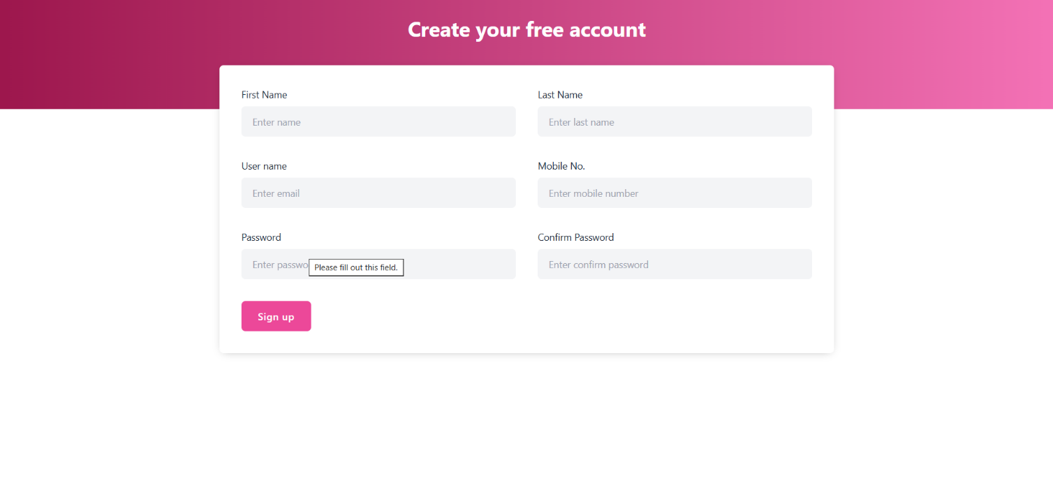**Registration page:**

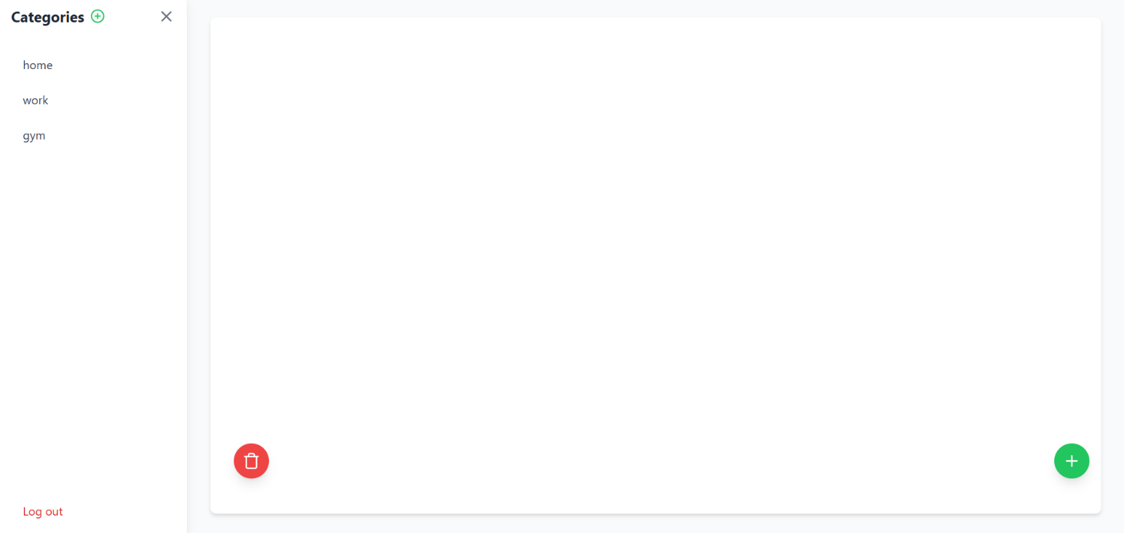**home page:**

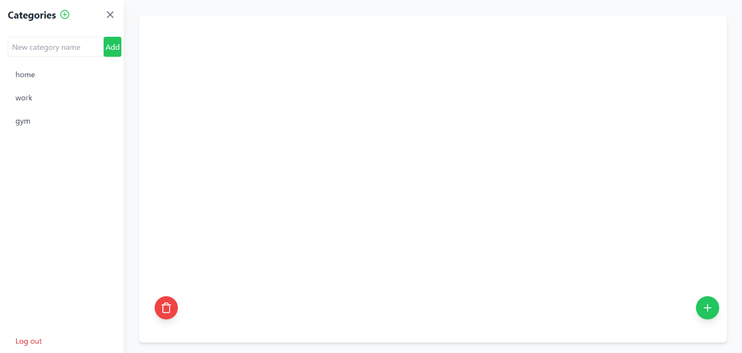**add new category:**

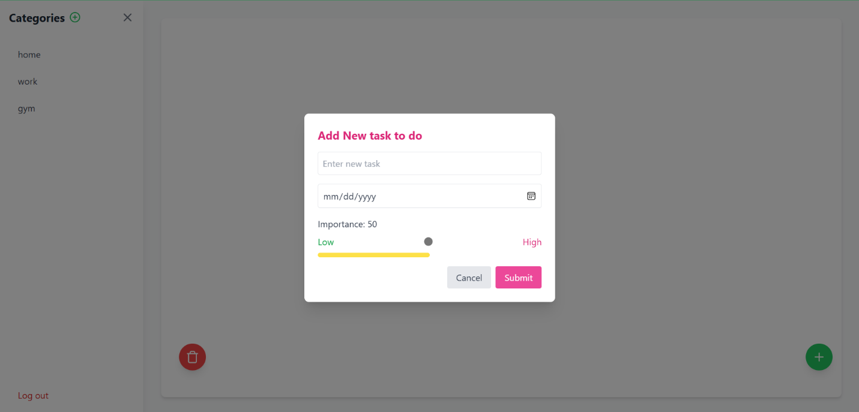**add new task:**

**External link for the code:**

GitHub repo: [braamost/toDo_list](https://github.com/braamost/toDo_list)